BI REPORTS
PYSPARK DF
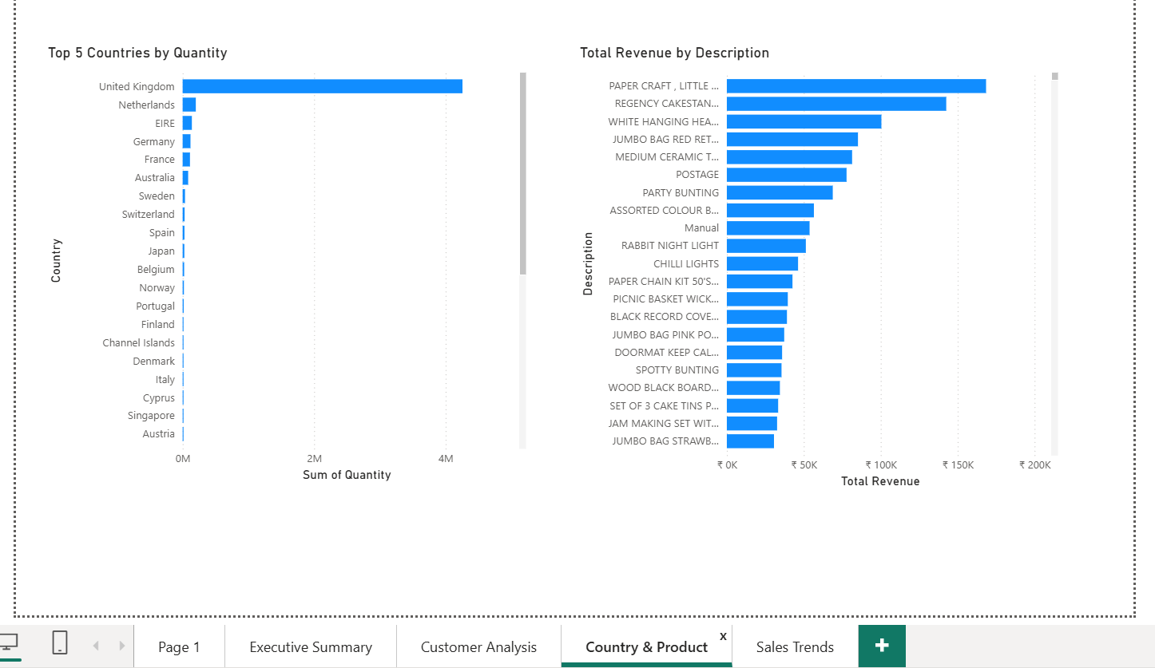
- Top 5 countries by quantity and total revenue by description

- Revenue by month
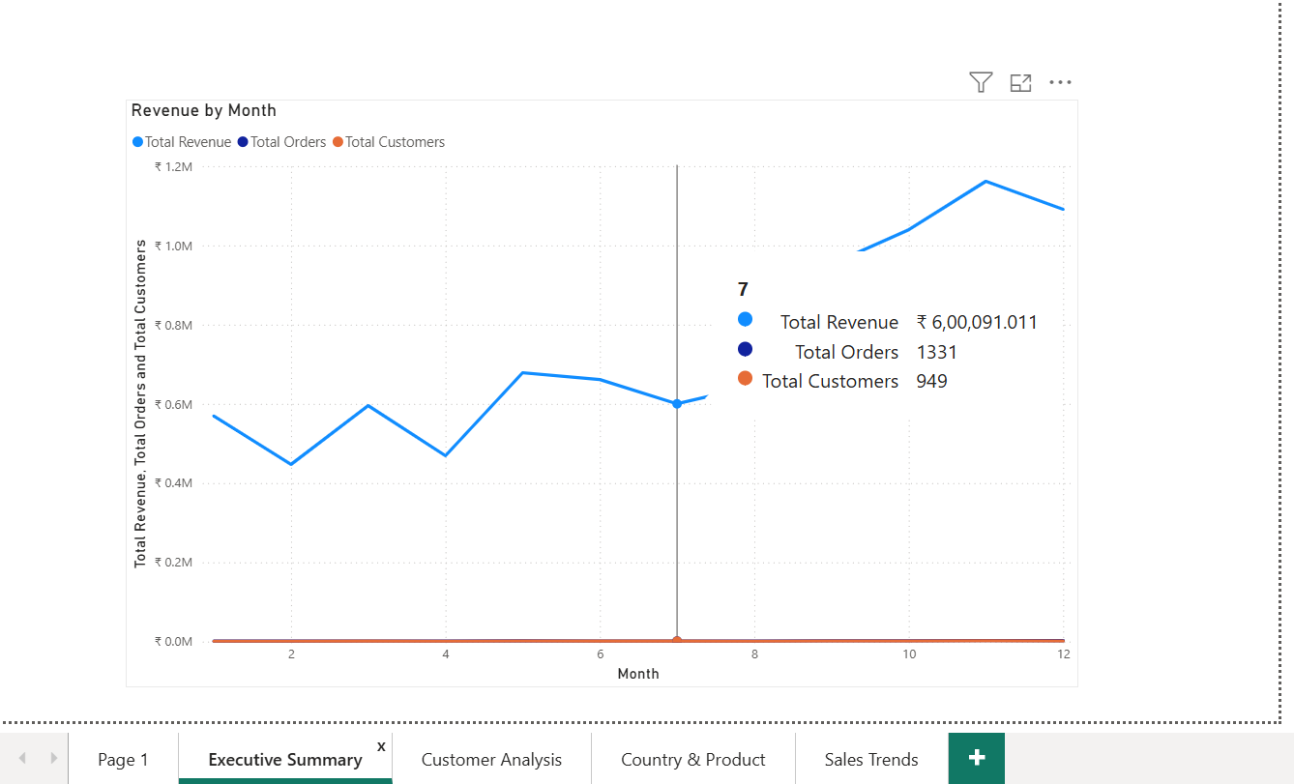

- Customer spend by customer ID
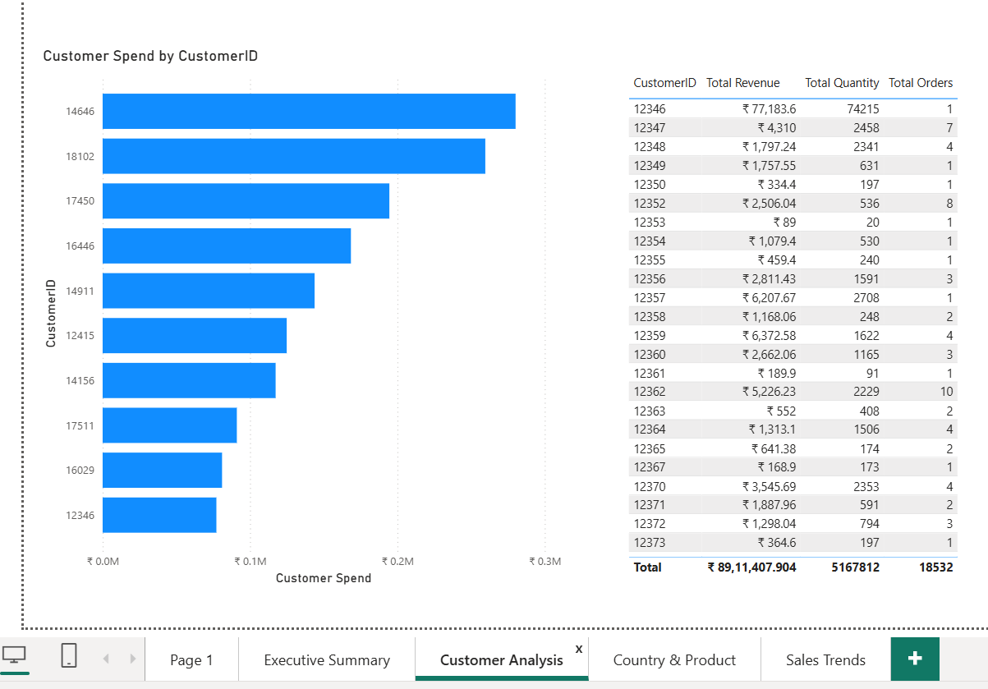

PYSPARK RDD
Report1: Unit price of each customer
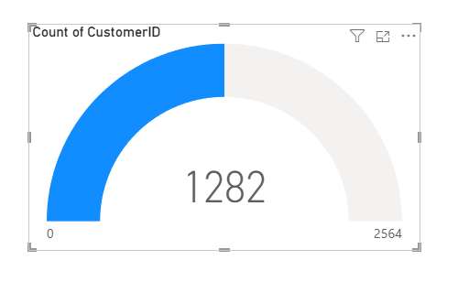

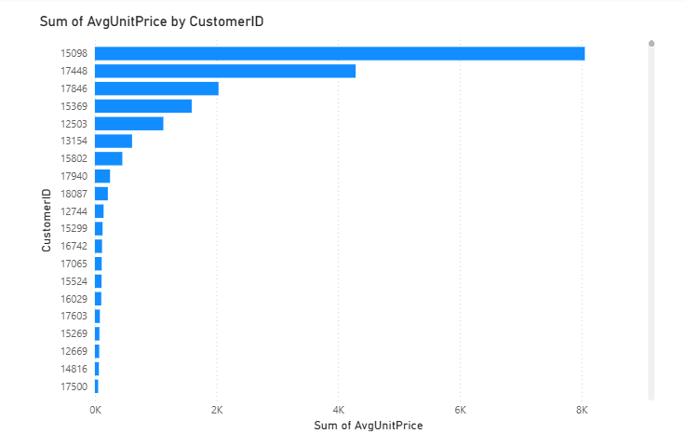
Report2: Average unit price per customer
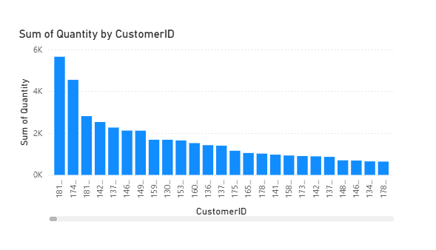
Report3: Display data description that contains ‘white’

HIVE
Report for Userstory1
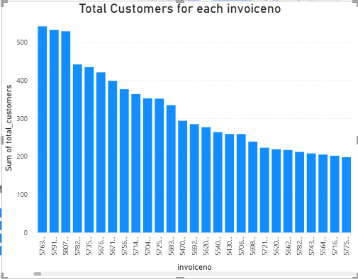

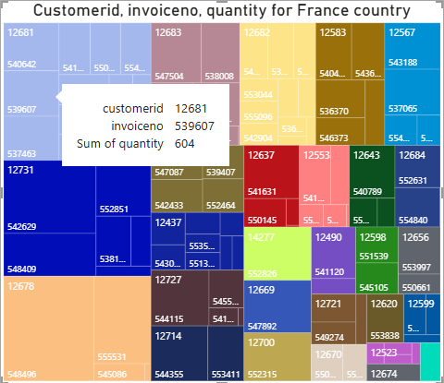
Report for userstory2

Report for userstory3
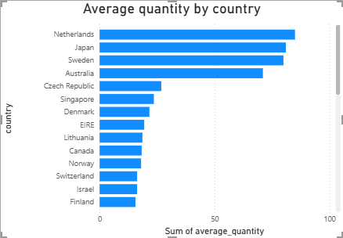

Report for userstory4
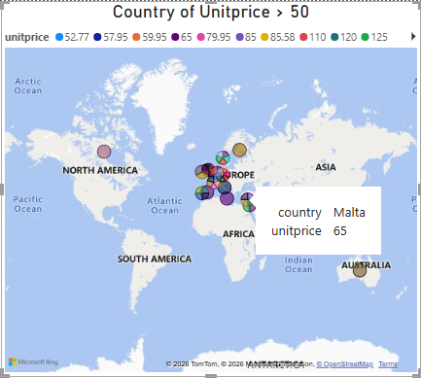

Report for userstory5
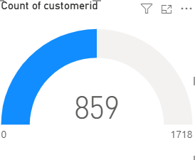

SPARK SQL
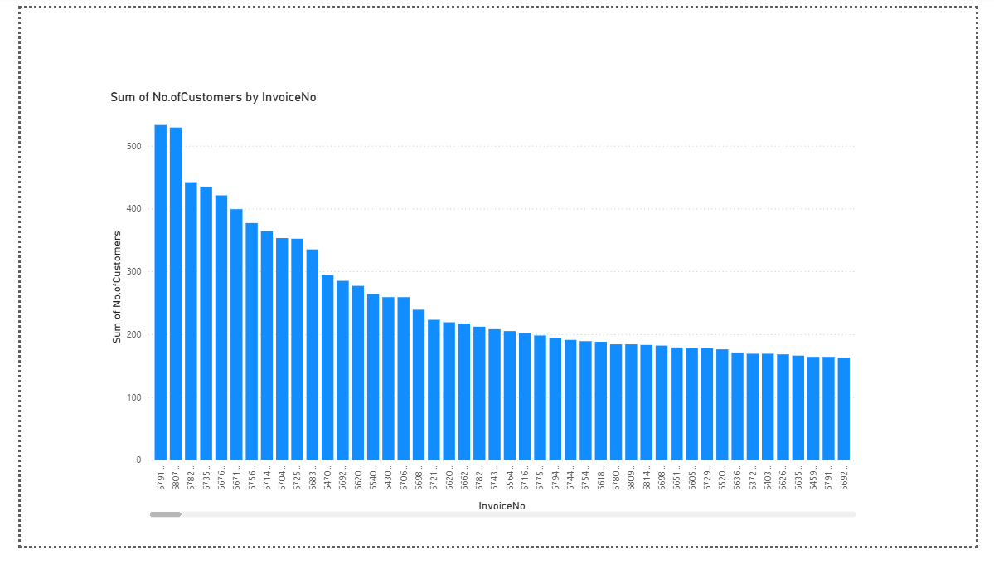
Report 1: To check the count of customers for each invoice in descending order
Report 2: Top 10 highest revenue generated stock codes?
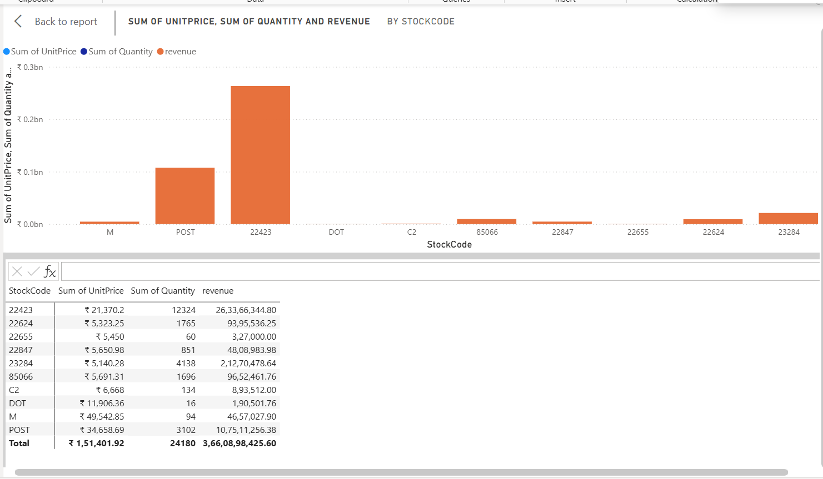

Report 3: Checking the stock codes unit price, revenue, quantity for each invoice
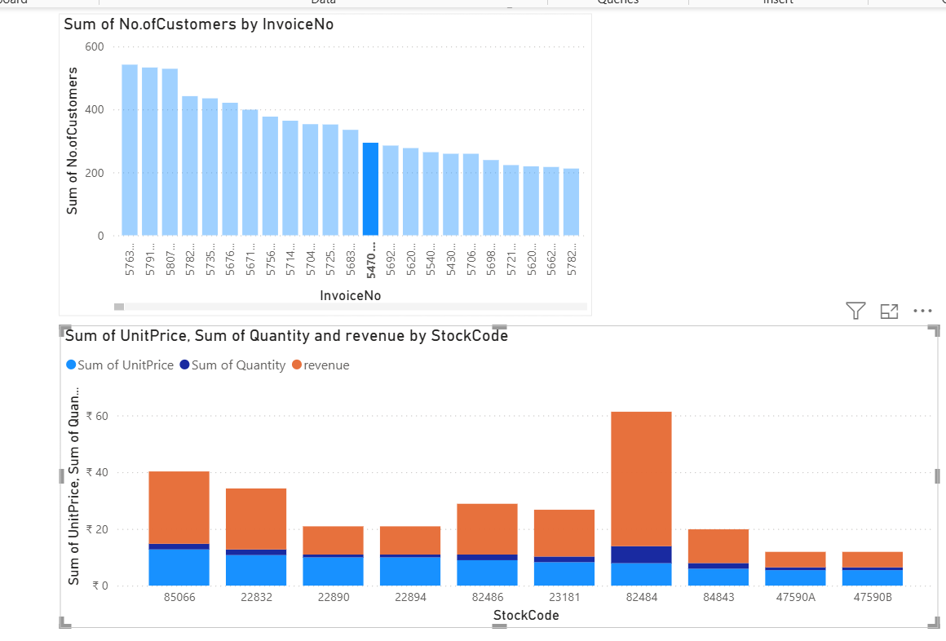

Report4: checking stock codes unit price, revenue and quantity for another invoice
